# Front-End Design Draft

COMPE 561 -Group 4

|Leonardo Roacho 824475360| Jacob Hosburg 822509838 | Gerardo Cerpa 819144749 | Anthony Vasquez 807090291| Jarrod Rowson 826453843|

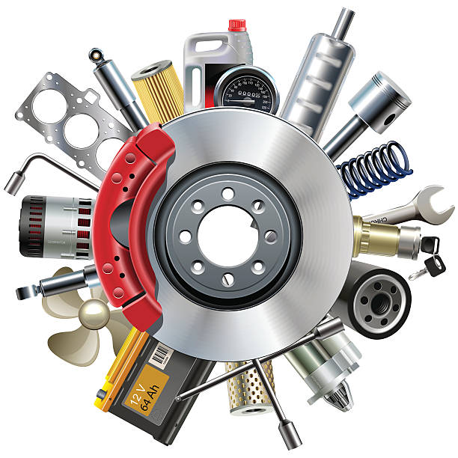

# INTRODUCTION

Welcome to CarHub, the premier online resource for vehicle lovers and automotive enthusiasts! CarHub is a vibrant and active website that connects like-minded people, facilitates trading, and offers a variety of tools and information on vehicles and their parts. Whether you're an avid collector, a do-it-yourself technician, or simply a fan of gorgeous vehicles, CarHub is your one-stop shop for all things automotive.

# TOOLS

1. DRAW.IO
2. HTML
3. CSS
4. JSON
5. GITHUB
6. PYTHON

# Website Overall Information: The website will have a WireFrame that will include a Login/Account System (Order History, etc…), Cart, Photo of parts/ featured brands. All of the next descriptions of each fixture will be connected together on the Web Site.

**Wireframe:**

At CarHub, we believe in providing a seamless and intuitive user experience. Our wireframe design ensures that every interaction within the website is thoughtfully planned and structured. Basically it will be a Userfriendly website that will be not hard to navigate, and it will be easy to find every option we provide. From the homepage to the individual sections like the shop, messages, groups and more, our wireframe layout allows for easy navigation and a clear understanding of the site's functionality.

**Shop:**

Explore our website's store area, where you can explore a wide range of automobile parts, accessories, and even cars themselves. You'll have access to high-quality components to enhance and customize your own car thanks to a comprehensive selection maintained by fellow enthusiasts. The CarHub store offers it all, from performance upgrades parts to eye-catching cosmetic improvements.

**Homepage:**

Our visually appealing site serves as the CarHub community's entry point. It will have a section from JDM to EURO cars or even Muscle cars. You'll discover a carefully chosen collection of highlighted automobiles, the most recent automotive parts, and fascinating material from our enthusiastic user community right here. Immerse yourself with gorgeous photography of car parts or even our car community groups will help you select the car parts you need for your car. This car community of automobiles from all around the world, will be the best friendly community ever.

**Wireframe Mockup:**

To provide a consistent user experience, we diligently created a wireframe model of CarHub's visual layout and interaction flow. This mockup gives an insight into the website's design and functionality, showing how visitors will browse through different parts, obtain content, and interact with the community.

**Messages:**

Through our chat tool, you can connect with other vehicle lovers, make friends, and share your knowledge. Whether you're looking for technical guidance or simply want to engage in vibrant discussions about your favorite automotive issues, the messaging tool is the ideal way to connect with like-minded people and build your network.

**Groups:**

Join and/or create groups centered around specific car models, brands, or automotive interests. Engage in in-depth discussions, share your experiences, and learn from fellow group members who share your car passion. CarHub's group offers a great platform for enthusiasts to come together and celebrate their love for cars. Groups can have different goals for their builds, they can either trade/buy car parts, or show their car to the website groups.

**Account:**

Personalize your CarHub experience by creating a dedicated account. Your account grants you access to exclusive features, enables you to showcase your car collection, car mods that you own on your car and allows you to manage your listings in the shop. It also serves as your gateway to connecting with other users, participating in forums, and staying updated with the latest happenings in the automotive world.

**Users:**

The CarHub user directory is a complete list of enthusiastic individuals who are members of the CarHub community. Explore the profiles of other automobile enthusiasts and interact with them via private chat or by joining shared interest groups. Expand your automobile network and meet new enthusiasts from all around the world.

# 

# 

# RESULTS (screenshots)

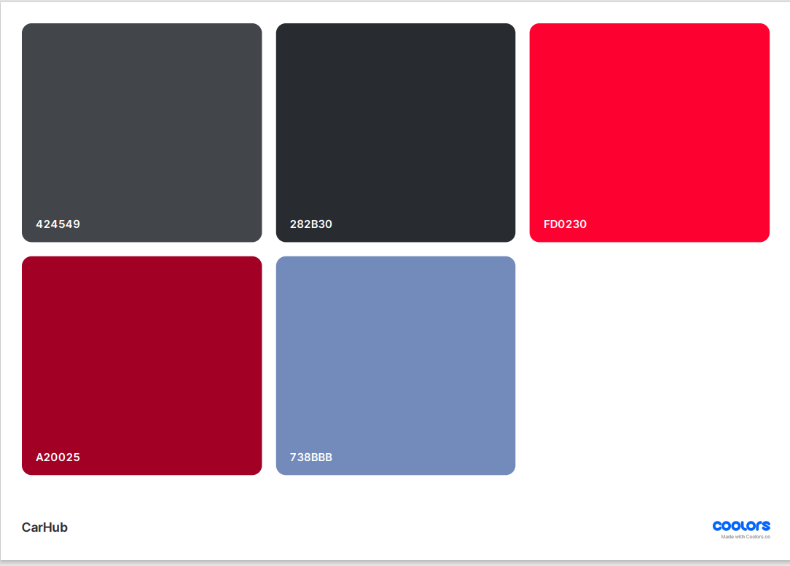

Figure 1: Colors for Web Site.

Next is the image for wireframe and the color scheme is not shown because we ran into issues where our web pages would be deleted. We will use the color palette above. Also, we chose to not put a cluster of connections between each webpage because every webpage can be accessed from the navigation bar.

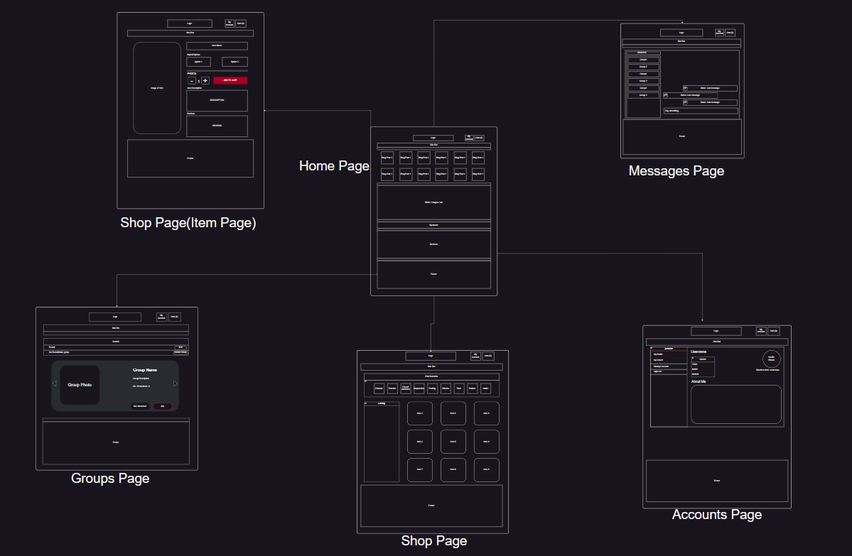

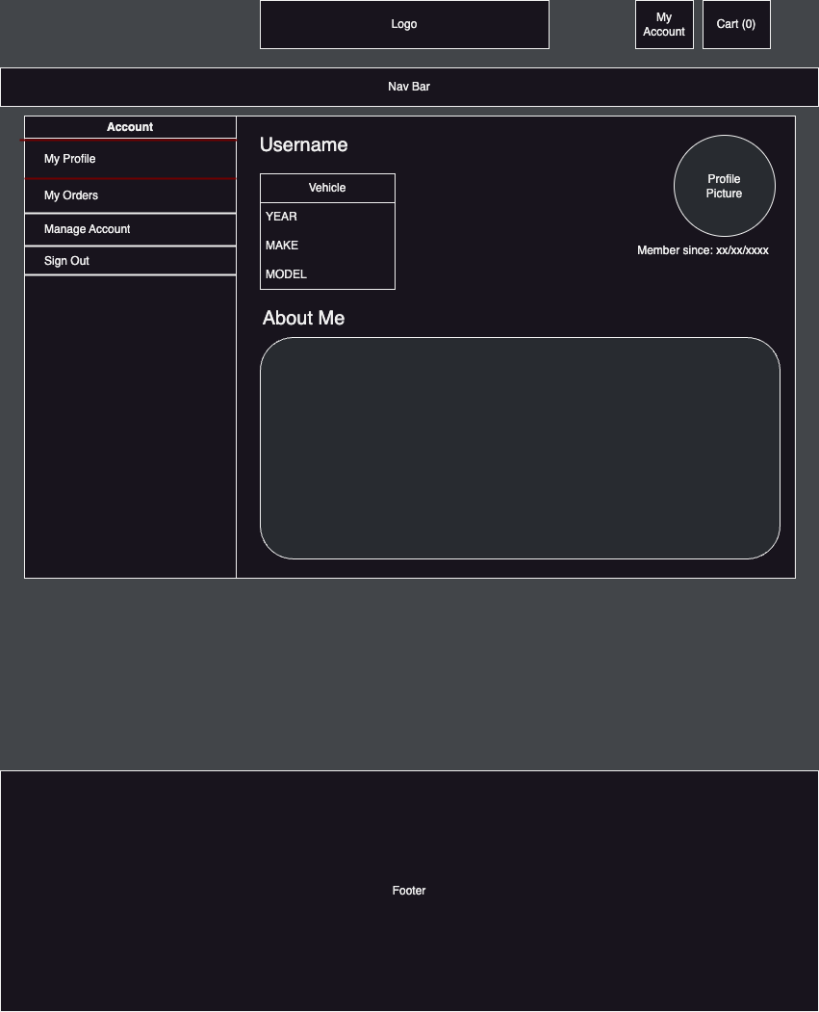

Figure 2: Account Web Page

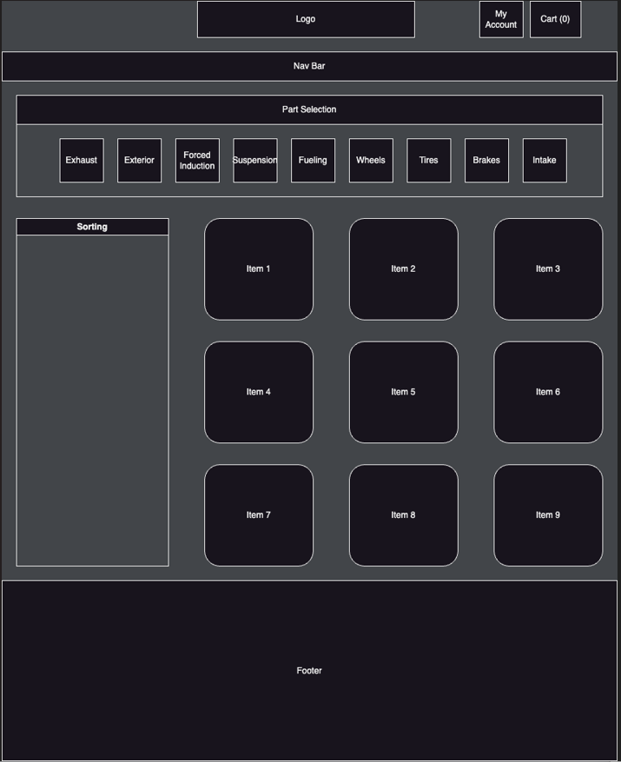

Figure 3: SHOP (Main) Web Page

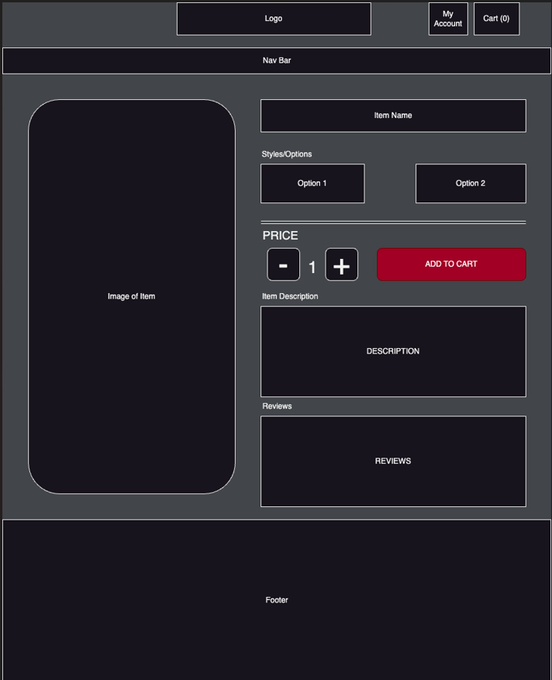

Figure 4: SHOP (Sub) Web Page

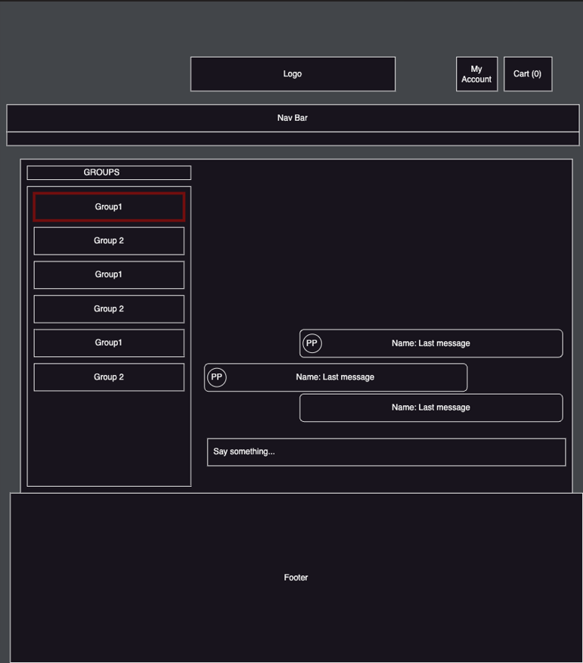

Figure 5: Messages

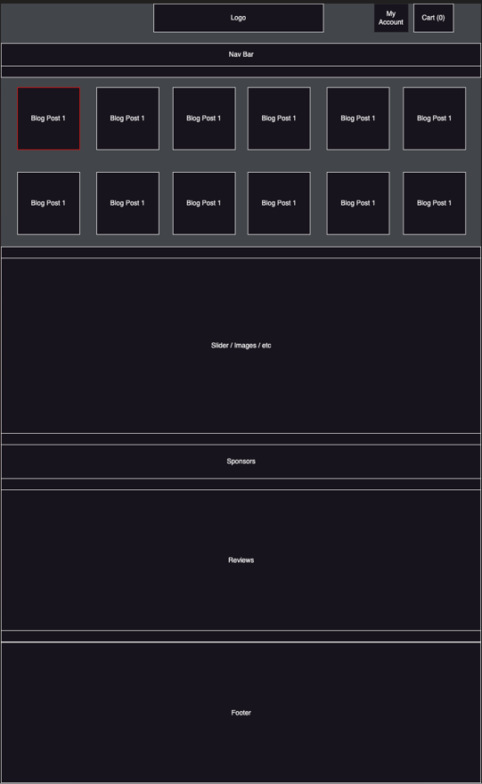

Figure 6: HOME Web Page

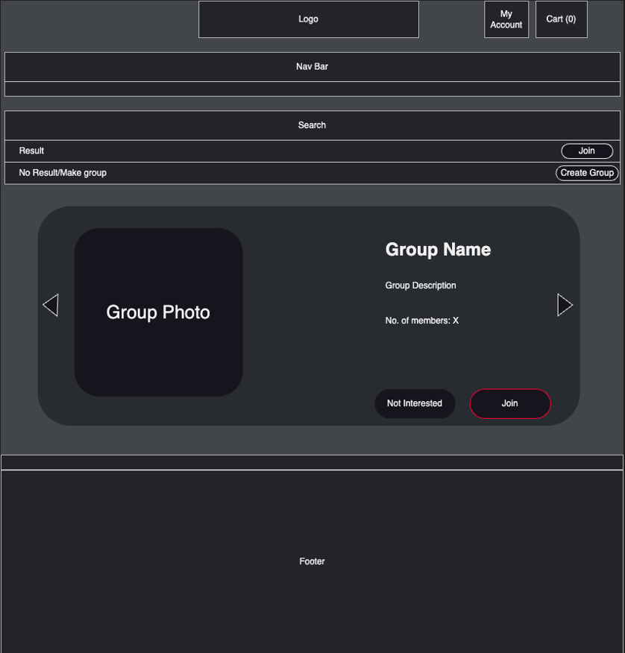

Figure 7: Groups Web Page

# CONCLUSION

CarHub is more than just a website; it's a dynamic community where vehicle enthusiasts can join together to share their expertise, swap automotive components, and celebrate their common passion for automobiles. Join us on CarHub, where you will discover a world of automotive love. Prepare to rev your engines on an exciting voyage through the motor world! This will be the theme of our website: to have the best “car” community, to make new friends, and buy/trade car parts.

# REFERENCES

1. <https://www.maperformance.com/>
2. <https://zociety.org/>
3. <https://www.z1motorsports.com/>